**HOME PAGE**

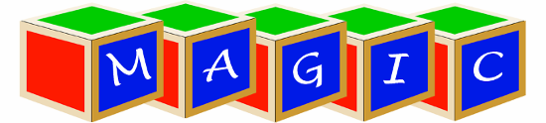

Building Block

Preschool & Childcare Center

**Two locations to serve you!**

**Contact Information Page**

928 Lincoln Highway

Fairview Heights, IL 62208

618-632-7339

5601 Old Collinsville Road

Fairview Heights, IL 62208

618-632-7338

e-mail address: [info@magicbuildingblock.com](mailto:info@magicbuildingblock.com)

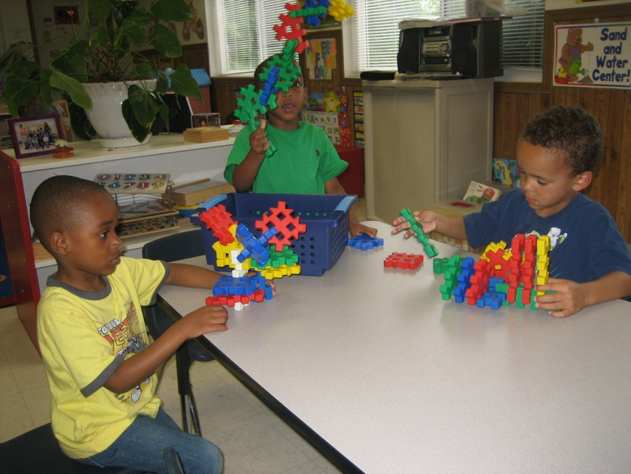

**PHILOSOPHY**

At Magic Building Block we appreciate the fact that each child is a unique individual. We expect and accept different temperaments and learning styles of the young children in our care. We believe the children learn through play and that the earl childhood years should be happy ones filled with a variety of meaningful hands-on experiences. We know that an integrated, well-planned program is essential to the social, physical, emotional, cognitive, and creative development of a child. We believe that the teacher of young children is a facilitator for learning. We believe that open communication must exist between home and school to maximize learning possibilities. It is the responsibility of the educators at Magic Building Block to set up the environment for learning and be active facilitators in the learning process.

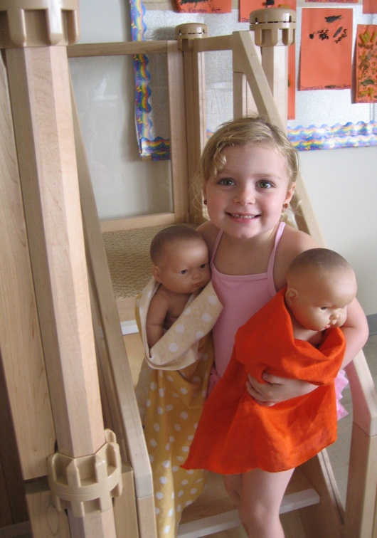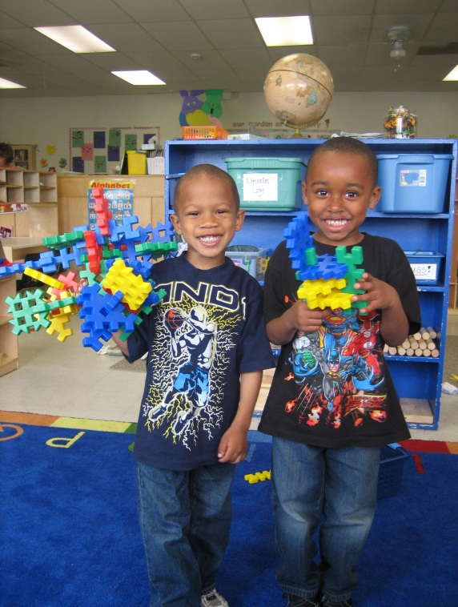

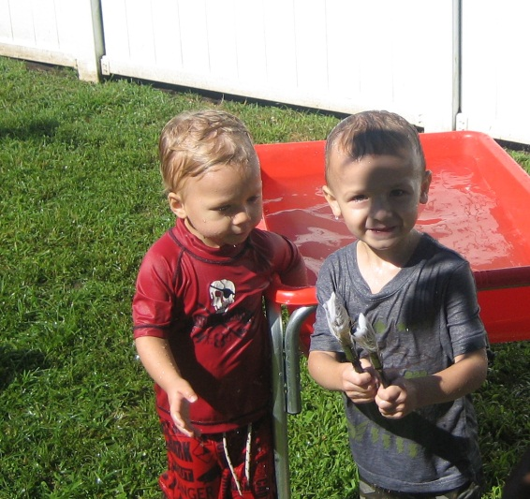

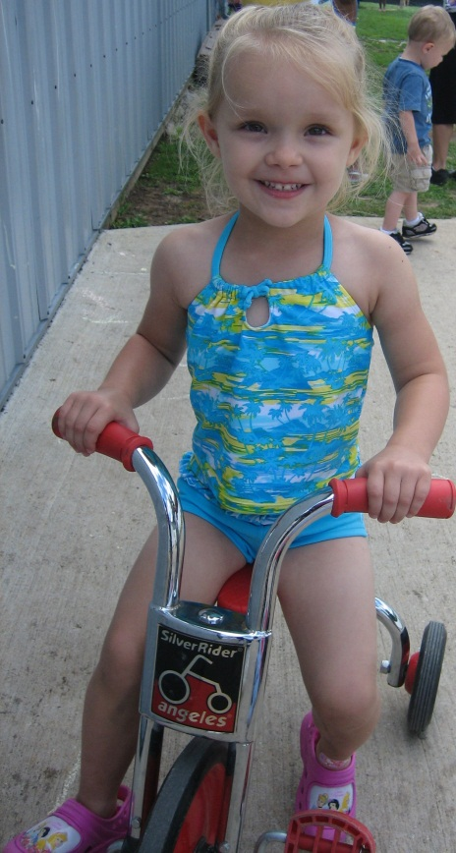

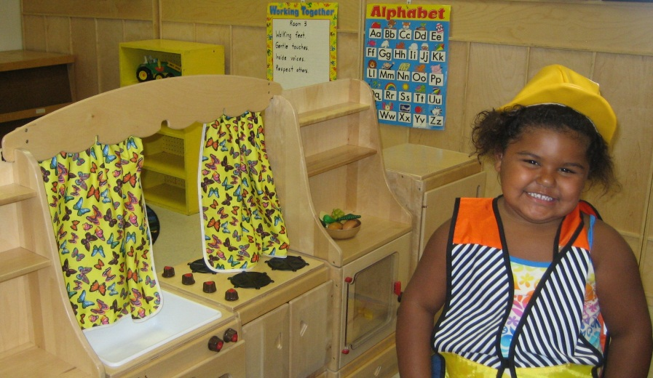

**Curriculum**

Children will have opportunities for learning by doing, self-expression and participation in a variety of creative activities. Activities will be planned in the areas of language arts, social studies, science, mathematics, health, music and motor development. Television will not be offered, nor will videos be shown.

In order to gather meaning of their world, infants and toddlers will be nurtured and guided to explore sensory (touch, smell, hear, see, and taste) and sensory-motor (kicking, rolling, crawling, etc) experiences.

Curriculum Benchmarks coincide with the Illinois State Board of Education’s Early Learning Standards. Curriculum is developed by assessing every child individually and using that information to develop a program that ensures that each child’s needs are met.

Magic Building Block is an open-ended program which will prepare children to use their creative and intellectual abilities. As you tour our center, you will see:

* a variety of manipulatives and games**;**
* materials to enhance artistic, dramatic, and block play;
* ideas and things to talk about, relate to, compare with, match, fit into, try out, reinforce, invent, discover, and enjoy;
* opportunities to “do it myself”

The most important thing that you will see at Magic Building Block is a

strong staff commitment to play – the only path to a child’s learning!

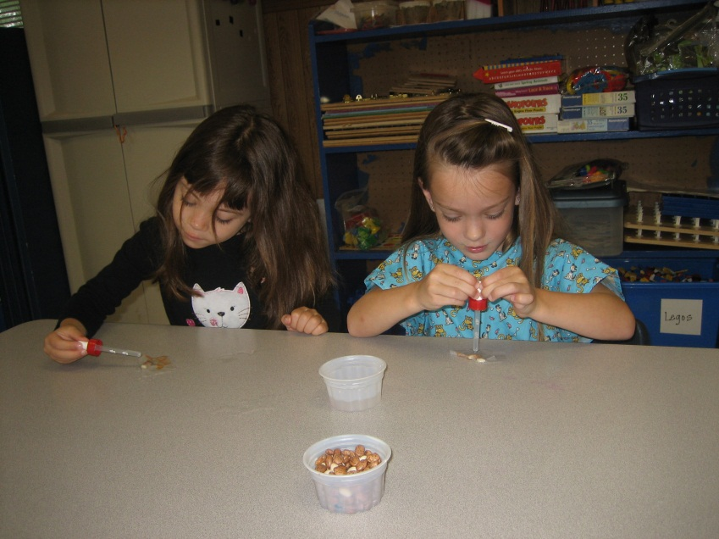

**Rate Information Page**

Weekly Tuition Rates:

INFANT – TODDLER ROOMS $225.00

TWOS CLASSROOMS $190.00

PRESCHOOL / PRE-KINDERGARTEN $175.00

Magic Building Block is a full day/full year program.

Hours of operation are 6:30 a.m. to 6:00 p.m. Monday through Friday.

